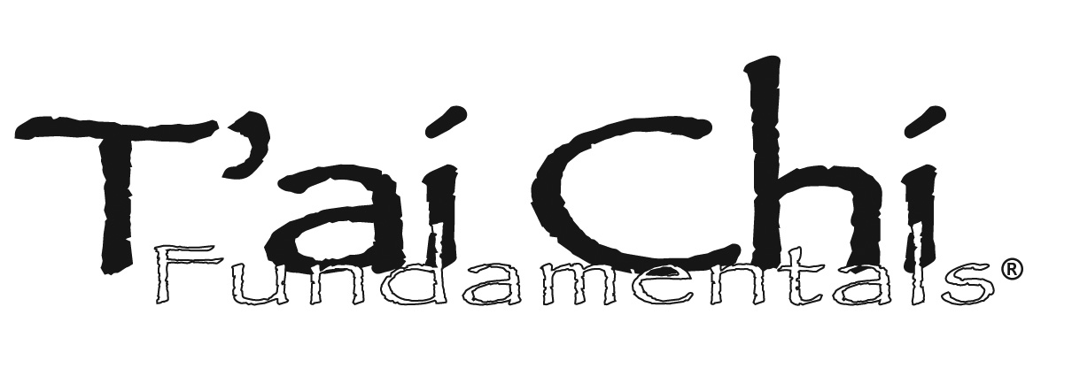

**Adapted Program**

**Professional Training Seminar**

### Madison, Wisconsin

**Applications for Optional Standing Support, Walker Support and Seated**

### July 11- 12, 2014

Provides you with tools for applying Tai Chi in your practice as a health care provider

### Instructor: Tricia Yu, MA

**Prerequisit**e: Attendance in Levels One-Two

**Options**: Two-day Course

"*A remarkable gift to the world of rehabilitation…*

*makes a very strong connection between the exercise*

*form and its applicability in the clinical environment…*

*brilliant and inspired work.”*

—Jennifer Bottomley PT, PhD,

Past President, Geriatric Section, APTA

**Participant Comments:**

*“This program is so flexible that it can be used both personally and professionally with relative ease.”*

*“This versatile mind/body program helps me stay focused and gives balance to both my body and my life.”*

*“ As a long term tai chi practitioner, TCF has helped me more clearly monitor my own movements and better teach my students.”*

***NMAPTA******12 Contact Hours*** New Mexico American Physical Therapy Association approval

**PROGRAM DESCRIPTION**

**The Tai Chi Fundamentals® Program** **(TCF)**

The first program of its kind, it provides a clear, systematic approach for mastering Tai Chi basics that builds from simple to complex patterns of movement. Integrates mind/body components of Tai Chi with clinical overview, movement analysis, therapeutic & functional applications. Provides a prequel to a lineage tai chi form, and creates a bridge between Tai Chi and the medical model.

**Program Elements:** movements taught in a motor development progression. Includes simple movements that can be practiced with walkers and have been modified for wheelchair use. Includes three elements:

***Movement Patterns*:** graded sequence of exercises that reinforce functional movements repeated throughout the Tai Chi form that have applications both as assessment and intervention tools. Includes basic elements of Qi Gong training.

***Fundamentals Form***: sequence of simple to more complex movements of modified Yang Style Tai Chi.

***Mind/Body Principles****:* foster mind/body integration; enhance breathing, relaxation, sensorimotor skills, proprioception and well-being.

**Development:** in 1996 by Tricia Yu, MA and Jill Johnson, MS, PT, targeting elements from traditional Tai Chi that enhance balance, coordination, strength and endurance.

**The TCF Program has been featured in:**  *PT Journal, Journal of Rehab Management*, *The Gerontologist*,APTA’s *GeriNotes, Medline Plus*, *Topics in Geriatric Rehabilitation.* *Journal of Asian Martial Arts,* *Wellness Program Management Advisor,* American College of Sports Medicine’s *Health and Fitness Journal,* Massage *& Bodywork.*

**OTHER LEVEL SEMINARS**

Visit [www.enhancingbalance.com](http://www.enhancingbalance.com) *or* [*www.taichihealth.com*](http://www.taichihealth.com)

**CERTIFICATION**

Requirements: 30 contact hours, application, fees, demonstration of movement proficiency, written exam. At least 6 months practice and study before applying. Complete information [www.taichihealth.com](http://www.taichihealth.com)

**REGISTRATION: TCF Seminar Levels 1 & 2**

*I am registering for the following date and location:*

___**January 24-25, 2015 TAOS, NM**

**___ July 11-12, 2015 Madison, WI**

___ **September 14-15, 2015, TAOS, NM**

______________________________________________Name Title/Credentials

______________________________________________ Street Address

______________________________________________City State zip

______________________________________________

Phone

______________________________________________ Email

**I wish to register for**: *Please Select One*

**____**  $350 Entire Course

____ $200 Level 1 only (Saturday)

____ $200 Level 2 only (Sunday)

___ $30 assessed if registering fewer than 20 days   
 in advance of workshop

**_________ TOTAL Registration**

**Course Materials:** *DVD___ or VHS ____*

____ $125 Adapted Program Set

**_______ GRAND TOTAL Enclosed**

**Register by credit card:** *call 575-776-3470*

#### Register by check: *payable to* Tricia Yu

#### *Mail registration c/o T*ai Chi Health

P.O. Box 756 Taos, NM 87571

***Refund Policy:***

*$50 cancellation fee up to 20 days prior to seminar date.*

*No refunds after 20 days prior to seminar date*

#### Questions? Call: 575-776-3470

#### Email: tyu@taichihealth.com

**COURSE CONTENT**

• TAI CHI OVERVIEW:

○ Background: history and cultural perspective/philosophy

○ Researched evidence

○ Elements: body mechanics, mind/body integration,

holistic balance and harmony

• SUPINE APPLICATIONS: Breathing, relaxation, pain management

• SEATED APPLICATIONS: Breathing and relaxation exercises

and sensing Qi

• STANDING APPLICATIONS:

○ Breathing, posture and functional relaxation

○ Flexibility, strengthening of upper and lower extremity

○ Mobility: ambulation, weight shifting and transitional

movements

○ Neuromuscular re-education: spinal stabilization and

co ordination

○ Balance: double and single leg

• PROGRAM ADAPTATIONS

• PROGRAM APPLICATIONS

• CERTIFICATION INFORMATION

**COURSE INSTRUCTOR:**

**Tricia Yu, M.A.** is a pioneer in integrating tai chi into medical model exercise therapy. She focuses on training, mentoring and certifying instructors in her Tai Chi Fundamentals® and ROM Dance® programs. Director of *Tai Chi Health*, and past director of the Tai Chi Center in Madison, WI, one of the oldest schools in the USA, she has introduced tai chi to thousands of people through her classes, presentations and professional courses She began learning tai chi and qigong in Taiwan in 1970 with Taoist Master Liu Pei Ch’ung and has studied Yang Style Cheng Man Ch’ing lineage form since 1974. She is certified by lineage Master Benjamin Pang Jeng Lo and Grandmaster William C.C. Chen.

Yu has presented courses to health care professionals for over

30 years. Her book, *Tai Chi Mind and Body* was translated

into 12 languages. Leaders in tai chi & health care endorse her

programs and materials.

**TAOS, NEW MEXICO COURSE LOCATION:**

Tai Chi Health Studio

51 Martinez Road, Arroyo Seco, NM 87514

575-776-3470

**QUESTIONS, DIRECTIONS, LODGING INFORMATION:**

**WEBSITE:** www.taichihealth.com **EMAIL:** [tyu@taichihealth.com](mailto:tyu@taichihealth.com)

**OFFICE:** 575-776-3470 **MOBILE:** 608-257-45171

**COURSE DESCRIPTION**

*Prerequisite: None. Open to Beginners*

This interactive seminar provides you with tools and skills to begin applying tai chi in your practice. The course teaches you, in a motor development progression, to perform basic movements of tai chi, and to apply tai chi as an assessment and intervention tool. The course combines lecture, movement labs, qigong training and discussions on biomechanics, applications and documentation. This course qualifies as partial contact hours fulfillment for *TCF Instructor Certification Levels One and Two*. For more information see CERTIFICATION.

**COURSE OBJECTIVES**

1) Demonstrate and teach all TCF Movement Patterns

2) Perform TCF Short Form

3) Describe TCF’s medical, biomechanical & functional benefits

4) Apply tai chi as therapeutic exercise for rehabilitation and

wellness programs

5) Document tai chi as part of therapeutic treatment intervention

6) Lead exercises in breath awareness, and centering

## **APPLICATIONS**

Balance dysfunction, orthopedic and neurological rehabilitation, pain management, sports cross training, cardiovascular and respiratory diseases, medically complex, chronic fatigue, fibromyalgia, and special populations. Use in hospitals, sub-acute, outpatient clinics, and home care. Teach groups of all ages and fitness levels in community wellness classes, health clubs, tai chi & martial arts schools, senior centers and long term care facilities.

**AUDIENCE**

Physical and Occupational Therapists, PTAs, COTAs, Nurses, Activity Directors, Recreational & Fitness Professionals, Tai Chi & other Martial Arts Instructors, Acupuncturists and Integrative Health Practitioners, and anyone wanting to jump-start or refine their Tai Chi practice.

**FEES**

**2-day Course: $350 1-day Course: $200**

**$30** late fee, **$50** cancellation. No refunds after 20 days prior to course.

**REQUIRED COURSE MATERIALS**

**Complete Program Set:** **$125** includes the following 2 sets:

* ***Professional Set:*** *TCF for Health Professionals and Instructors* text and video/DVD.
* ***Personal Practice Set****: Tai Chi Mind & Body* text and *TCF: for Mastering Tai Chi Basics* instructional video/DVD

**Or Personal Practice Set only:** *$55 does not include*

*biomechanics analysis.*

***Complete Program Set is required for Certification***

**AGENDA**

**DAY ONE: Level One 6 hours**

**Instruction in All Movement Patterns**

8:30 am On-Site Registration

9:00-10:30 Tai Chi Overview and Evidence

Movement Lab Section 1 with Analysis:

10:45 Centering/ Breathing Exercises

Movement Lab Complete Section 1

12:15 LUNCH ONSITE Bring your own

12:45 -2:15 Seated Adaptations Section 1

Movement Lab Section 2 with Analysis

2:30 TCF for Evaluation and Treatment

Documentation and Reimbursement

Movement Lab Section 3 with Analysis:

Seated Adaptations Sections 2-3

Partner Teaching Practicum: Centering

4:00 ADJOURN

**DAY TWO: Level Two 6 hours**

**Form Instruction Section One**

**Movement Pattern Partner Teaching Practicium**

9:00- 10:30 Tai Chi Energize! Warm-ups

Movement Lab: Review All Patterns

Partner Teaching Practicum: Section 1

10:45 Movement Lab: Beginning Form ROM Dance®/Group Wellness App.

Mind Body Principles of Tai Chi

Partner Teaching Practicum: Sections 2-3

Integrating Tai Chi into Treatment

12:15 LUNCH Mindful Eating

12:45-2:00 Supine or Seated Mindfulness

Sensory awareness Progression

Movement Lab: Form Section 1

Case Study Presentations Preparation

2:15 Presenting TCF to peers and Public

Wrap Up

Movement Review: Flow Form

3:30 ADJOURN

*Certification Information

Movement Review: Flow Form

4:30 ADJOURN